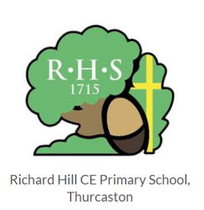

**Richard Hill CE Primary School**

Learning Spellings Menu

As well as look cover write check you could also try some of these ideas to practise your spellings. You can learn your spellings in lots of different ways – be creative!

